WHAT ARE YOU DOING THIS WINTER?
Are you tired of sitting on the couch, flipping through the TV channels, waiting for spring to arrive?
Do you want to have some fun, meet new friends, and have an adventure while exploring the Edmonton region?
Why not check out the Edmonton Outdoor Club!
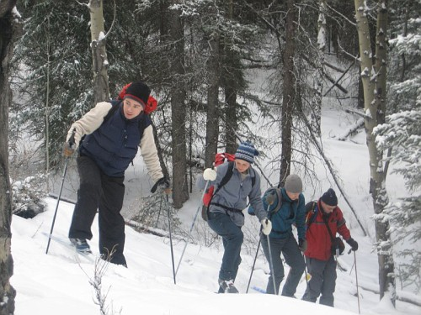 |  | 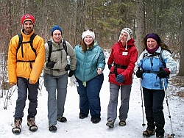

With your FREE membership, you can take part in:
Adventure Sports: | hiking, camping, backpacking, mountain biking, paddling, skiing, skating, snow shoeing, etc.
Social activities: | parties, spectator sporting events, pool (billiards), theatre and comedy evenings, etc.
Travel: | trips to various parts of Canada and the U.S., and possibly beyond

No experience? No Problem! Most EOC events cater to those with minimal or no experience.
Visit our website, and become our newest member! www.edmontonoutdoorclub.com
edmontonoutdoorclub.com | edmontonoutdoorclub.com | edmontonoutdoorclub.com | edmontonoutdoorclub.com | edmontonoutdoorclub.com | edmontonoutdoorclub.com | edmontonoutdoorclub.com | edmontonoutdoorclub.com | edmontonoutdoorclub.com | edmontonoutdoorclub.com | edmontonoutdoorclub.com | edmontonoutdoorclub.com | edmontonoutdoorclub.com | edmontonoutdoorclub.com | edmontonoutdoorclub.com | edmontonoutdoorclub.com | edmontonoutdoorclub.com | edmontonoutdoorclub.com | edmontonoutdoorclub.com | edmontonoutdoorclub.com | edmontonoutdoorclub.com | edmontonoutdoorclub.com | edmontonoutdoorclub.com | edmontonoutdoorclub.com | edmontonoutdoorclub.com | edmontonoutdoorclub.com | edmontonoutdoorclub.com | edmontonoutdoorclub.com

